Tech Stack: Spotify

Spotify is a UK-based music streaming service. The application is available on a wide variety of platforms, including Windows, Mac OS X, Linux for desktops and iOS, Android, BlackBerry, Windows Phone/Mobile, among others. The application uses the ‘Freemium’ model, which allows free access with certain limitations. The desktop app allows unlimited streaming for 6 months supported by ads, after which users will be limited to 10 hours a month, divided into 2.5 hours per week. The mobile app allows a trial period of 30 days, after which the user must purchase a premium account to continue using it. Spotify offers an ‘Unlimited’ subscription for $5 which removes the restrictions for the desktop application and a ‘Premium’ subscription which removes the limitations on both the desktop and mobile app. Accounts and their associated music library are synced across platforms. Spotify has contracts with several music labels, distributing a certain amount of their revenue from ads and subscriptions back to the label.

The service offers a library of approximately 20 million songs, searchable by artist, album, song title, label, or genre. Spotify also allows users to create custom playlists, and offers a radio service of their own. The application also allows users to install sub-apps which add additional elements of functionality such as finding lyrics for tracks, music discovery, playlist generation, and integration with other services like Last.fm (allows users to “scrobble” their Spotify tracks).

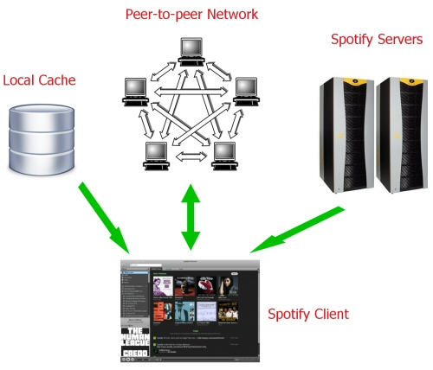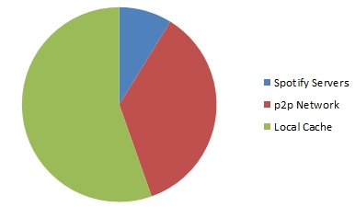 The software Spotify uses is proprietary and uses DRM to protect their content. The software uses a peer-to-peer system that appears to operate as a hybrid between a traditional stream service, connecting to a central hub, and BitTorrent clients, connecting to other peers, as well as utilizing a cache for replaying songs. The client utilizes a mix of these three sources to stream music, putting priority on local caches and the peer-to-peer network. The more popular the track is, the more likely it will be streamed via peers over the Spotify servers. This puts minimal strain on their servers and allows for efficient scalability by utilizing their userbase as an additional content server. The mobile client, however, relies entirely on the Spotify servers. BitTorrent users will be familiar with the system of locating peers who have the track you are looking for in their local cache, but unlike BitTorrent clients, this all happens behind-the-scenes and is entirely handled by the Spotify client. For example, a BitTorrent client might allow you to set download/upload speeds, max/min number of peers to allow for downloading/uploading; Spotify sets a max of 60 peers for downloading, and 4 peers for uploading with the rate of downloads/uploads being controlled by the client. Users can, however, change the quality of the music though you must have a premium subscription to do so. The size of each peer’s cache is limited to around 5GB and Spotify’s servers have a capacity of 290TB.